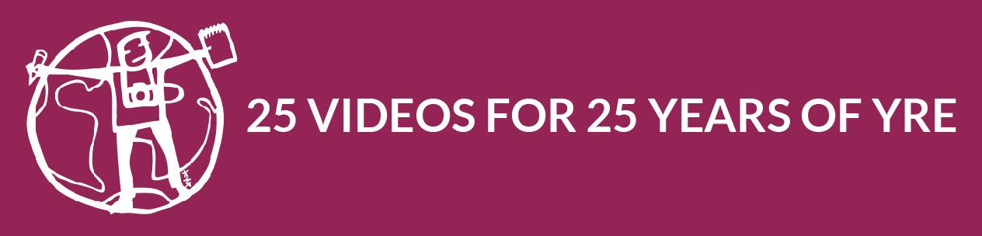

Submission Form – Special 1 Minute Video Competition

Country
Name of school
Name of participant(s)
Age of participant(s)
Title of video

The submission form and the original file should be sent directly to YRE International (kristina@fee.global) either through WeTransfer or Google Drive. The deadline is 18 December 2018.
Read the competition requirements here: http://www.yre.global/stories-news/2018/9/25/yres-25th-anniversary-special-1-minute-video-competition

Declaration of consent for processing of personal information and use of video submitted
When signing up to this competition, you agree that we can process your personal data provided in this submission form and given to us during the competition. We process the data so that we can register your participation, judge the submission and save what you have submitted and publish your submission if you are chosen as a winner. All winners will be saved in our archives.
You always have the option to withdraw your consent and your submission to the competition.
The Data Controller is:
Foundation for Environmental Education
Scandiagade 13, 2450 Copenhagen SV, DENMARK
+45 70 22 24 27
info@fee.global

Thank you for helping celebrate YRE’s 25th Anniversary!

